PROJEC REPORT TEMPLATE

1. INTRODUCTION
   1. Overview

Our project is to analyse the LokSabha election conducted in 2019.The objective is to conduct a comprehensive quantitative analysis of the candidates participated in the election.We collect the data of the candidates Electoral performance,educational qualifications,criminal records,constituency,parties,etc...

* 1. Purpose

The purpose of our project is to check the overall performance of the candidates participated in the election.We can analyse the winners in each state and which party win in more states and so on

1. PROBLEM DEFINITION & DESIGN THINKING
   1. Empathy Map

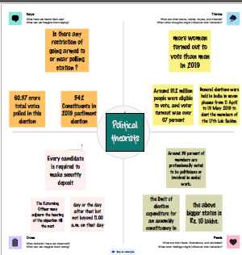

* 1. Ideation & Brainstorming Map

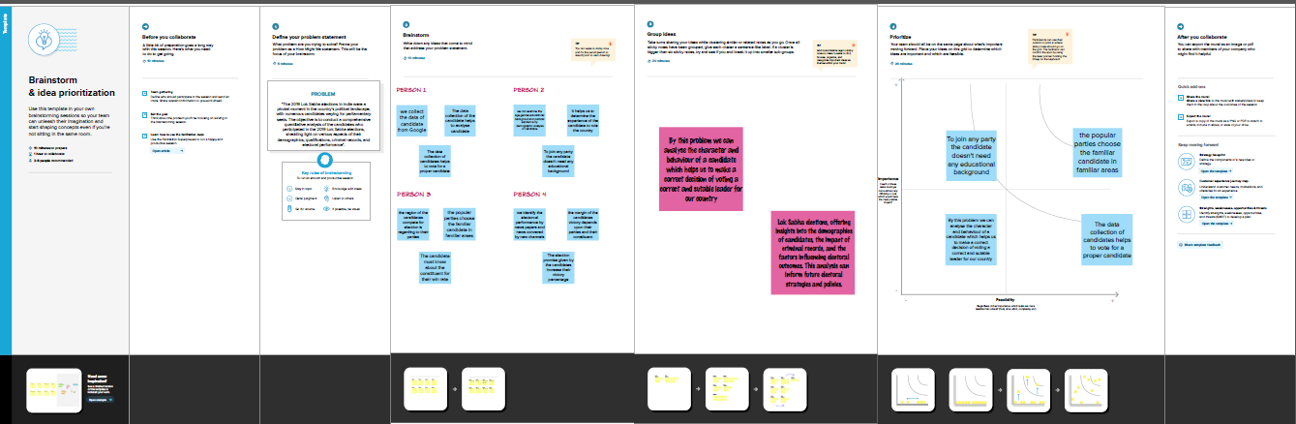

1. RESULT

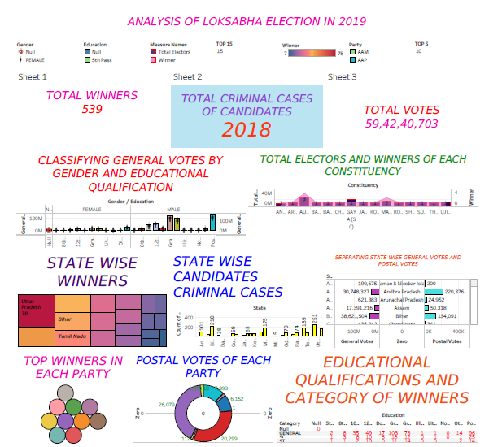

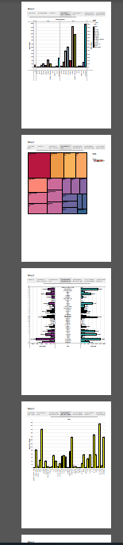

1. ADVANTAGES & DISADVANTAGES

The advantage of the project is we can analyse all the data of the candidates .We can visualize it bt some graphs,charts,etc…

The disadvantage of the project is we can use only two or three informatons of candidates for a single chart or graph

1. APPLICATIONS

The project mainly applied to the next lok sabha election for the data extraction of candidates who were participated in the previous election.

1. CONCLUSION

From this project we understand the basic about the election.How can they choose their party and thus their educatational qualification and so on .We finally make a well presented graph by using datas we have collected.

1. FUTURE SCOPE

We have like to add some informations like the candidates assests before the election and after the election . This information would help to analyse the candidates so easily and correctly